TASK 1

1. Create virtual machines connection according to figure:
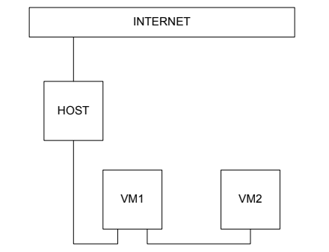

2. VM2 has one interface (internal), VM1 has 2 interfaces (NAT and internal). Configure all network
interfaces in order to make VM2 has an access to the Internet (iptables, forward, masquerade).
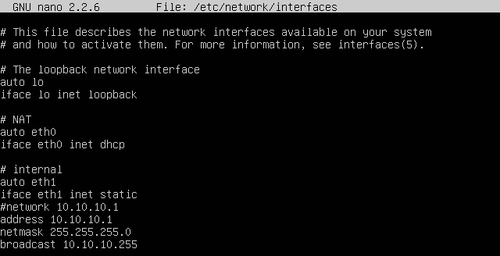
VM1:
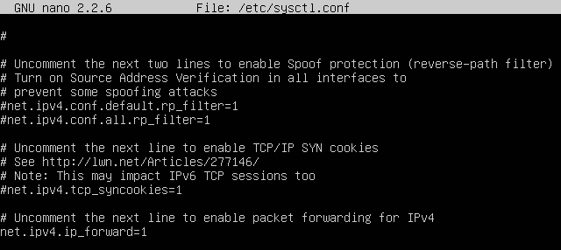

VM2:
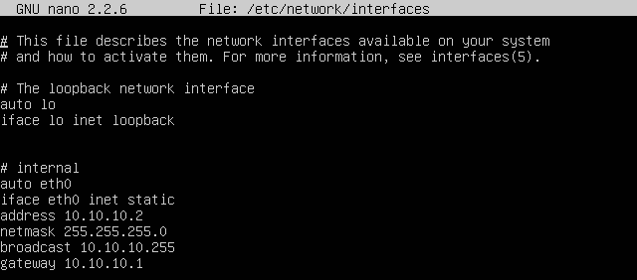
3. Check the route from VM2 to Host.
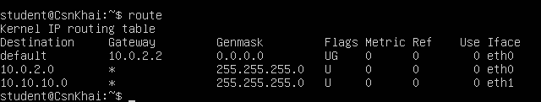
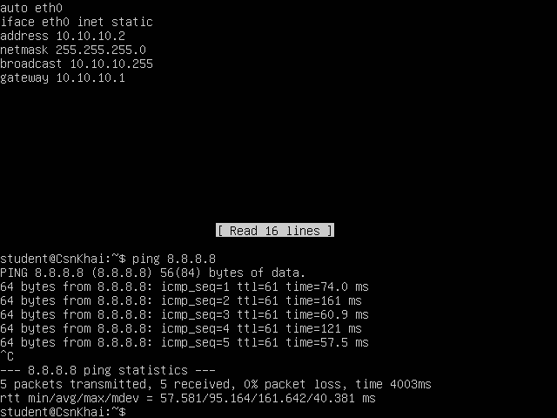
4. Check the access to the Internet, (just ping, for example, 8.8.8.8).
5. Determine, which resource has an IP address 8.8.8.8.

$ whois 8.8.8.8
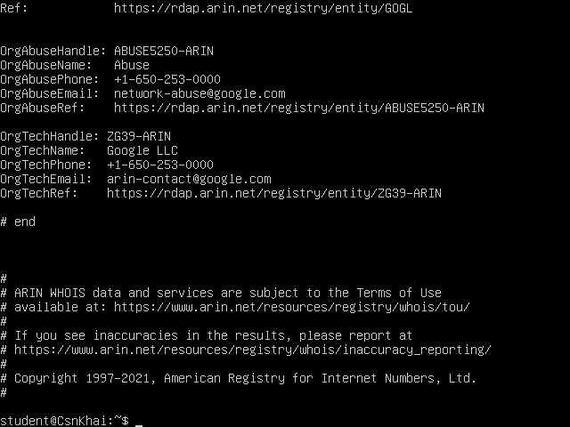
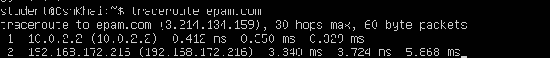
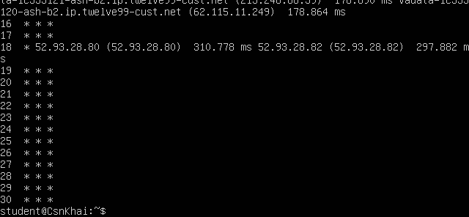
6. Determine, which IP address belongs to resource epam.com.

7. Determine the default gateway for your HOST and display routing table.
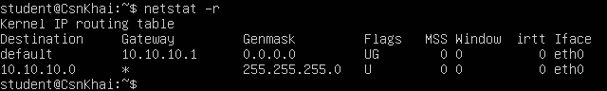

8. Trace the route to google.com.

